Industrial production of L – Lysine

Introduction

- There are 20 naturally occurring amino acids, which are required for the synthesis of variety of proteins besides other biological functions.
- However, all these 20 amino acids need not to be taken in the diet.
- Based on the nutritional requirements amino acids are grouped into two classes: essential and non-essential.
- The amino acids which cannot be synthesized by the body and therefore, need to be supplied through the diet are called essential amino acids.
- Opposite to that the amino acids which can be synthesized by the body and therefore, need not to be supplied through the diet are called non-essential amino acids.
- They are required for proper growth and maintenance of the individual.
- L- Lysine is commercially important amino acid as it is one of essential amino acids.
- Generally L- Lysine is used in the animal feed industry as feedstuff additive.
- It is not used solely but mixed with several common livestock like cereals which do not have enough amount of L-Lysine.
- Thus, protein quality of certain foods (e.g. wheat based foods) is improved resulting in an improved growth and tissue synthesis.
- It is mainly used for mono gastric animals like humans, rats, pigs, dogs, cats, horses and rabbits.
- It improves the feed quality by increasing absorption of other amino acids.
- There are various chemical & biochemical methods for L-Lysine production.
- Lysine production is based on fermentation of carbohydrates like, beet and cane sugar or starch sugars.
- • In 1978 first fermented L-lysine was produced by Japanese Company “Kyowa Hakko Kogyo”.

Fermentation Microorganisms

- Gram+ve Corenebacterial strains like Corynebacterium glutamicum, Brevibacterium flavum etc. are used for industrial production.
- Kinoshita et al (1958) first reported the fermentative production of L-lysine using homoserine auxotrophs of Corynebacterium glutamicum.
- This auxotroph requires L-homoserine or a mixture of L-threonine and L- methionine for growth, and produces L- lysine in the fermentation broth.

- L-lysine is not destroyed by the organism during the fermentation, because it also lacks the ability to produce l-lysine decarboxylase.

- 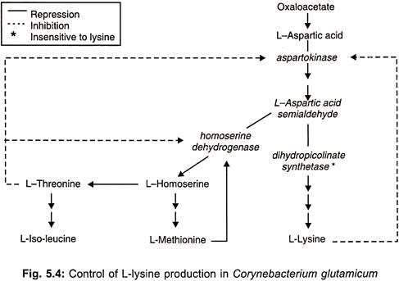

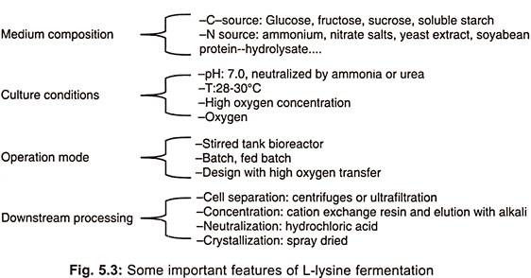

Preparation of Medium:
Both the inoculum and fermentation media contain glycerol, corn-steep liquor as carbon sources and ammonium hydrogen phosphate, as nitrogen source. In addition, calcium carbonate is also used in the production medium. The levels of all of the nutrients are kept lower in the inoculum medium. Apart from supplying carbon source, the corn steep liquor also provides L-lysine required for the initial growth of auxotroph of E. coli. The pH of the medium is maintained at neutral, to slightly alkaline level (pH 8.0).

Fermentation Process:
Sufficient quantities of sterilized medium is fed into the fermenter. inoculum of E. coli is add(4.0%) to the fermenter. The fermentation is carried out for 3 days at 28 to 30°C temperature. The level of L-lysine quantity provided to E. coli is very important, because providing low quantities, less than optimum, results in the back mutation and more quantities results in the feedback control of lysine biosynthesis both of which badly affect the yield.
Through a sequence of enzymatic steps during first stage of fermentation glycerol is converted into L, L-diaminopimelic acid, which is partially converted into D, L- isomer and mesodiaminopimelic acid by the action of diaminopimelic acid racemase enzyme. metabolites accumulate in the fermentation broth because auxotrophic E. coli lacks diaminopimelic acid decarboxylase enzyme. Hence, it cannot be converted into L-lysine. The broth contains approximately 40% L, L-isomer and 60% mesoisomer of diaminopimelic acid.
In the second half of the fermentation, 1-2 days old culture of A. aerogenes is added to the fermentation broth formed at the end of first fermentation process. The microorganism is allowed to grow for one day at 24°C. After sufficient growth occurs toluene is add to the fermentation broth which causes lysis of cells of A. aerogenes, due to which the enzyme diaminopimelic acid decarboxylase is liberated into the fermentation broth.
By this time most of the L, L-diaminopimelic acid is converted into meso-diaminopimelic acid by the action of diaminopimelic acid racemase enzyme. The meso-diaminopimelic acid is completely converted into L-lysine by the action of diaminopimelic acid decarboxylase

Uses of L-Lysine:
L-lysine is useful in many fields:
1. L-lysine is an essential amino acid required for the human nutrition.
2. It is used as supplementary for cereal proteins.
3. Protein quality of certain foods like wheat (based foods) is improved by addition of L-lysine which results in the improved growth and tissue synthesis.
4. It is used as a nutraceutical.

